Make a color wheel with items around your house!  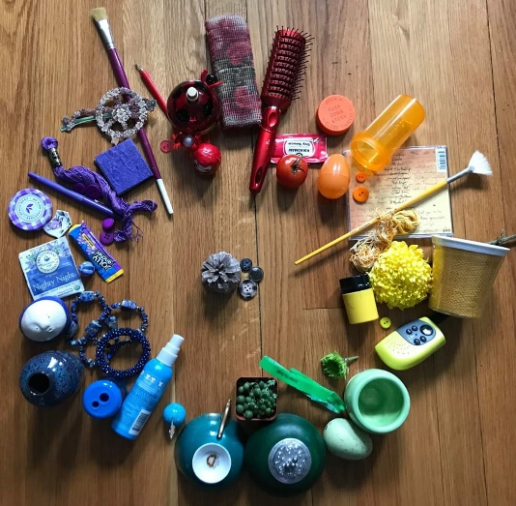 | Pretend you’re an architect and sit in a room with quiet music playing. Draw the room!  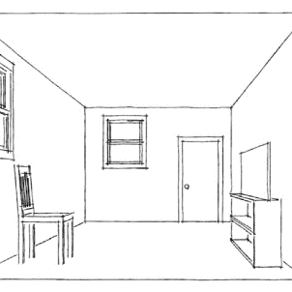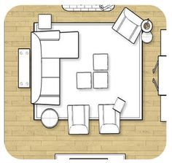 | Find an empty toilet paper roll. What can you make with it?  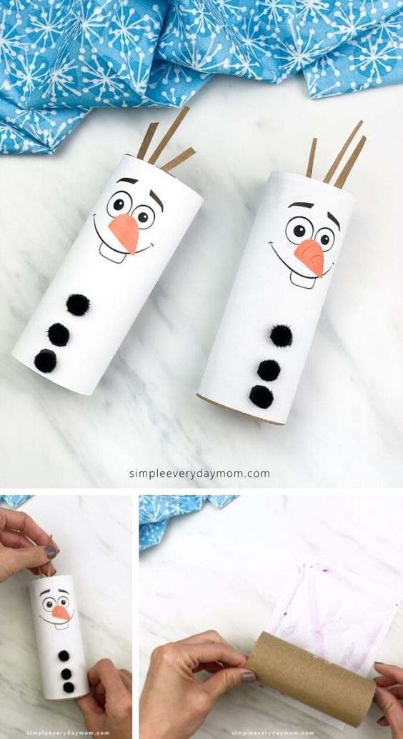
Draw what you did today and draw BIG!  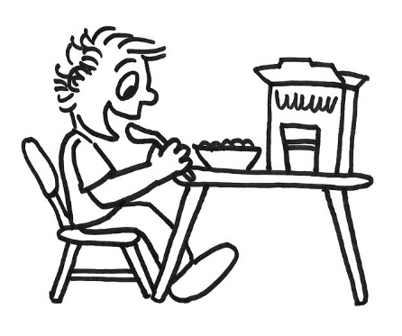 | Make a treasure map and have someone in your house try and use it!  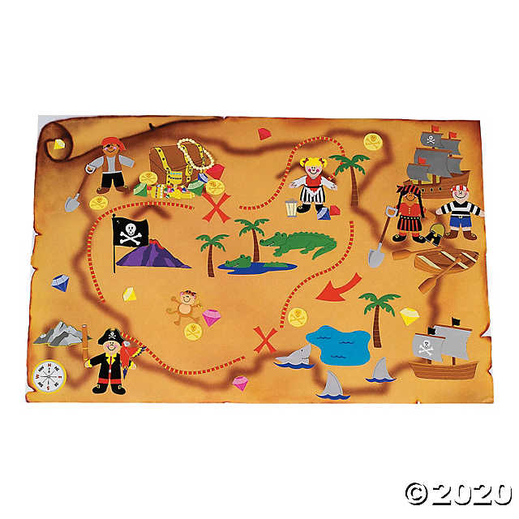 | Grab a piece of foil. Draw a fun design with lines, shapes and patterns using sharpies!  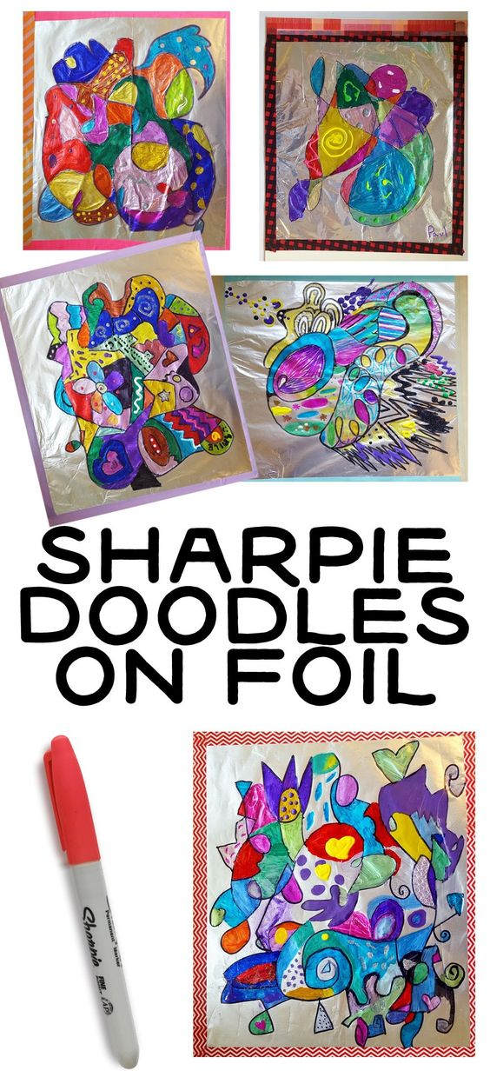
Draw a picture using visual texture. Now go and find some items around the house that have texture!  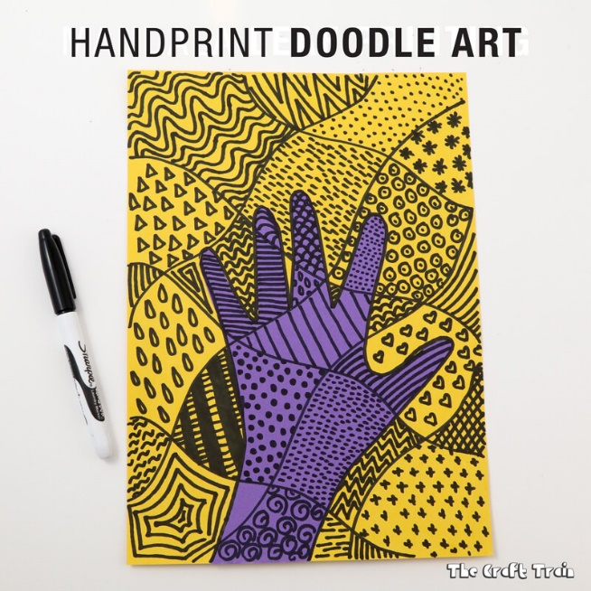 | Make your own air-dry clay and create!  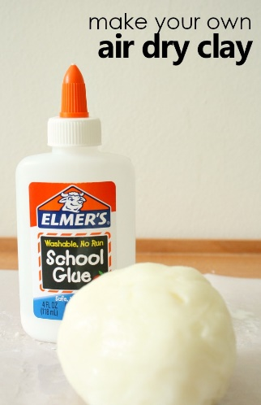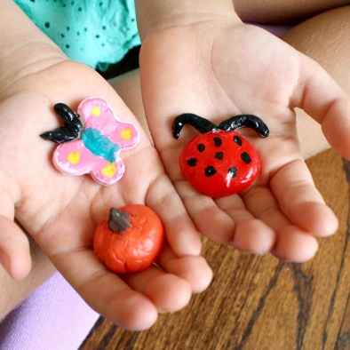 | Find something in nature to draw. Look out your window or go in your back yard!  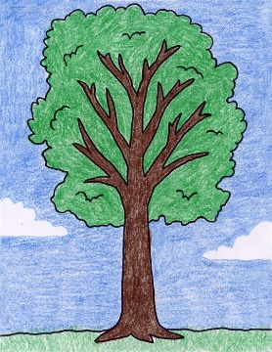

MATERIALS YOU’LL NEED
- 4 oz bottle of Elmer’s Washable School Glue
- 4 oz cornstarch
- 2 tbsp baby oil (or substitute with vegetable oil)-We s
- 2 tbsp lemon juice (or substitute with white vinegar)

HOW TO MAKE YOUR OWN AIR-DRY CLAY
Start by pouring Elmer’s School Glue into a bowl. Add in the cornstarch.
Mix to combine the two ingredients a bit. And don’t worry if a bit of the mixture gets on your little one’s hands or the table. Elmer’s glue and cornstarch are both washable, so clean up will be quick and easy when you’re finished.
Then add in your oil and lemon juice. Continue mixing until the texture is like a smooth frosting. Microwave for 30 second then stir. Microwave again for 15 seconds.
Once the dough is cool enough to touch knead it like you would with a play dough or bread dough recipe.
Just when you think this recipe was a total flop and there is oil oozing off your hands, give it just a bit longer. Somewhere in there is a magic transformation, and you’ll finish with a nice malleable clay that your child can create with.

NOW IT’S TIME TO CREATE

